CCNP period 6-7

redistribution

By Jeffrey Xu

6/13/19

**Purpose:**

In the world today, there are many companies constantly being swallowed up by larger companies due to various reason. And when that happens, 2 or more networks are needed to be merged together. And if you don’t want to tire yourself out in making a whole new network, you can redistribute the two different routing protocols to make it so that they can match with each other. It is really useful in saving time.

**Background:**

When redistributing 2 different routing protocols, there are many different things that play into it. The most important is keeping the metrics the same. The metrics, or K values include K1: Bandwidth, K2: Load, K3: Delay, K4: Reliability, and K5: MTU. These metrics are used in eigrp. By default, only bandwidth and delay are enabled. You can enable which ever ones you want to change. By enabling these then redistributing the routes into ospf or another routing protocol, they are able to have network connectivity.

**Lab setup:**

I used 4 2901 routers for this lab, setup ospf on routers 0 and 1. And eigrp on routers 1, 2, and 3. Between routers 1 and 2 have an AS number of eigrp 15 while between 3 and 3 have an AS number of 20. I redistributed between routers 1 and 2

Topology:

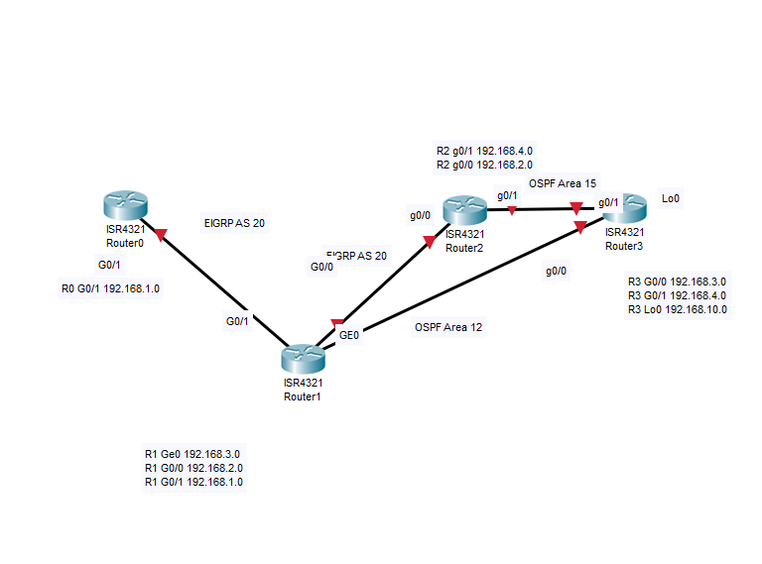

R0 Configs:

*hostname R0*

*boot-start-marker*

*boot-end-marker*

*no aaa new-model*

*memory-size iomem 5*

*ip cef*

*no ipv6 cef*

*multilink bundle-name authenticated*

*voice-card 0*

*license udi pid CISCO2901/K9 sn FTX1704Y03G*

*license accept end user agreement*

*license boot module c2900 technology-package securityk9*

*license boot module c2900 technology-package uck9*

*vtp domain cisco*

*vtp mode transparent*

*redundancy*

*interface Embedded-Service-Engine0/0*

*no ip address*

*shutdown*

*interface GigabitEthernet0/0*

*no ip address*

*duplex auto*

*speed auto*

*interface GigabitEthernet0/1*

*ip address 192.168.1.1 255.255.255.0*

*duplex auto*

*speed auto*

*interface Serial0/0/0*

*no ip address*

*shutdown*

*clock rate 2000000*

*interface Serial0/0/1*

*no ip address*

*shutdown*

*clock rate 2000000*

*interface GigabitEthernet0/1/0*

*no ip address*

*shutdown*

*duplex auto*

*speed auto*

*router eigrp 20*

*network 192.168.1.0*

*ip forward-protocol nd*

*no ip http server*

*no ip http secure-server*

*control-plane*

*mgcp profile default*

*gatekeeper*

*shutdown*

*line con 0*

*line aux 0*

*line 2*

*no activation-character*

*no exec*

*transport preferred none*

*transport input all*

*transport output pad telnet rlogin lapb-ta mop udptn v120 ssh*

*stopbits 1*

*line vty 0 4*

*login*

*transport input all*

*scheduler allocate 20000 1000*

*end*

R1 Configs:

*hostname R1*

*boot-start-marker*

*boot-end-marker*

*no aaa new-model*

*memory-size iomem 10*

*ip cef*

*no ipv6 cef*

*multilink bundle-name authenticated*

*voice-card 0*

*license udi pid CISCO2901/K9 sn FTX1528859X*

*license boot module c2900 technology-package securityk9*

*license boot module c2900 technology-package uck9*

*license boot module c2900 technology-package datak9*

*vtp domain cisco*

*vtp mode transparent*

*redundancy*

*interface Embedded-Service-Engine0/0*

*no ip address*

*shutdown*

*interface GigabitEthernet0/0*

*ip address 192.168.2.1 255.255.255.0*

*duplex auto*

*speed auto*

*interface GigabitEthernet0/1*

*ip address 192.168.1.2 255.255.255.0*

*duplex auto*

*speed auto*

*interface Serial0/0/0*

*no ip address*

*shutdown*

*clock rate 2000000*

*interface Serial0/0/1*

*no ip address*

*shutdown*

*clock rate 2000000*

*interface GigabitEthernet0/1/0*

*ip address 192.168.3.1 255.255.255.0*

*duplex auto*

*speed auto*

*router eigrp 20*

*network 192.168.1.0*

*network 192.168.2.0*

*redistribute ospf 1 metric 1000 900 245 255 1*

*distance eigrp 90 105*

*router ospf 1*

*redistribute eigrp 20 subnets*

*network 192.168.3.0 0.0.0.255 area 12*

*ip forward-protocol nd*

*no ip http server*

*no ip http secure-server*

*control-plane*

*mgcp profile default*

*gatekeeper*

*shutdown*

*line con 0*

*line aux 0*

*line 2*

*no activation-character*

*no exec*

*transport input all*

*scheduler allocate 20000 1000*

*end*

R2 Configs:

*hostname R2*

*boot-start-marker*

*boot-end-marker*

*no aaa new-model*

*memory-size iomem 10*

*ip cef*

*no ipv6 cef*

*multilink bundle-name authenticated*

*voice-card 0*

*license udi pid CISCO2901/K9 sn FTX1520806U*

*license accept end user agreement*

*license boot module c2900 technology-package securityk9*

*license boot module c2900 technology-package uck9*

*vtp domain cisco*

*vtp mode transparent*

*redundancy*

*interface Embedded-Service-Engine0/0*

*no ip address*

*shutdown*

*interface GigabitEthernet0/0*

*ip address 192.168.2.2 255.255.255.0*

*duplex auto*

*speed auto*

*interface GigabitEthernet0/1*

*ip address 192.168.4.1 255.255.255.0*

*duplex auto*

*speed auto*

*interface Serial0/0/0*

*no ip address*

*shutdown*

*clock rate 2000000*

*interface Serial0/0/1*

*no ip address*

*shutdown*

*clock rate 2000000*

*interface GigabitEthernet0/1/0*

*no ip address*

*shutdown*

*duplex auto*

*speed auto*

*router eigrp 20*

*network 192.168.2.0*

*redistribute ospf 1 metric 1000 900 245 255 1*

*distance eigrp 90 105*

*router ospf 1*

*redistribute eigrp 20 subnets*

*network 192.168.4.0 0.0.0.255 area 15*

*ip forward-protocol nd*

*no ip http server*

*no ip http secure-server*

*control-plane*

*mgcp profile default*

*gatekeeper*

*shutdown*

*line con 0*

*line aux 0*

*line 2*

*no activation-character*

*no exec*

*login*

*transport input all*

*scheduler allocate 20000 1000*

*end*

R3 Configs:

*hostname R3*

*boot-start-marker*

*boot-end-marker*

*no aaa new-model*

*memory-size iomem 5*

*ip cef*

*no ipv6 cef*

*multilink bundle-name authenticated*

*voice-card 0*

*license udi pid CISCO2901/K9 sn FTX180180LY*

*license accept end user agreement*

*license boot module c2900 technology-package securityk9*

*license boot module c2900 technology-package uck9*

*vtp domain cisco*

*vtp mode transparent*

*redundancy*

*interface Loopback0*

*ip address 192.168.10.1 255.255.255.0*

*interface Embedded-Service-Engine0/0*

*no ip address*

*shutdown*

*interface GigabitEthernet0/0*

*ip address 192.168.3.2 255.255.255.0*

*duplex auto*

*speed auto*

*interface GigabitEthernet0/1*

*ip address 192.168.4.2 255.255.255.0*

*duplex auto*

*speed auto*

*interface Serial0/0/0*

*no ip address*

*shutdown*

*clock rate 2000000*

*interface Serial0/0/1*

*no ip address*

*shutdown*

*clock rate 2000000*

*router eigrp 20*

*distance eigrp 90 105*

*router ospf 1*

*area 12 range 192.168.3.0 255.255.255.0*

*area 15 range 192.168.4.0 255.255.255.0*

*network 192.168.3.0 0.0.0.255 area 12*

*network 192.168.4.0 0.0.0.255 area 15*

*network 192.168.10.0 0.0.0.255 area 0*

*ip forward-protocol nd*

*no ip http server*

*no ip http secure-server*

*control-plane*

*mgcp profile default*

*gatekeeper*

*shutdown*

*line con 0*

*line aux 0*

*line 2*

*no activation-character*

*no exec*

*transport preferred none*

*transport output lat pad telnet rlogin lapb-ta mop udptn v120 ssh*

*stopbits 1*

*line vty 0 4*

*login*

*transport input all*

*scheduler allocate 20000 1000*

*end*

Show Commands:

*R2(config-router)#do sh ip eigrp topology 192.168.4.0*

*EIGRP-IPv4 Topology Entry for AS(20)/ID(192.168.2.2) for 192.168.4.0/24*

*State is Passive, Query origin flag is 1, 1 Successor(s), FD is 20906*

*Descriptor Blocks:*

*0.0.0.0, from Redistributed, Send flag is 0x0*

*Composite metric is (20906/0), route is External*

*Vector metric:*

*Minimum bandwidth is 1000 Kbit*

*Total delay is 900 microseconds*

*Reliability is 245/255*

*Load is 255/255*

*Minimum MTU is 1*

*Hop count is 0*

*Originating router is 192.168.2.2*

*Default networks accepted from incoming updates*

*Redistributing: ospf 1*

*EIGRP-IPv4 Protocol for AS(20)*

*Metric weight K1=1, K2=1, K3=1, K4=1, K5=1*

*NSF-aware route hold timer is 240*

**Problems:**

A few problems that I ran into to include not activating the k values that are down by default so they wouldn’t change. Another problem would include using the wrong routers and sometimes some simple mistakes such as wrong ip addresses, but I figured it all out in the end.

**Conclusion:**

I feel like this lab is a lab we should remember if we are going into networking in the future. It will be really helpful when you run into a problem similar to this one were you need to combine 2 different networks with different routing protocols.